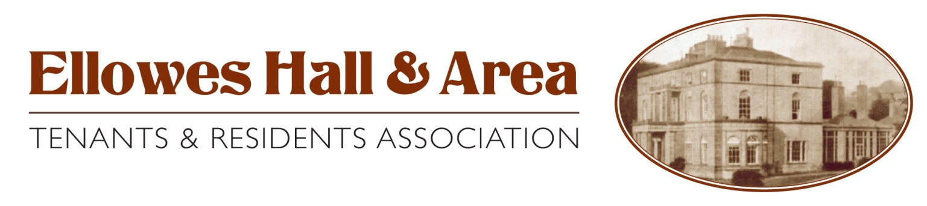

AGM -20 JULY 2013 CHAIR’S REPORT

We are now in our fourth year as a TRA and have decided that to encompass the area we cover it is time to change our logo and name as above and have included the new housing estate Foresters Fold into our area. In this our 4th year we have seen some of our committee members retire and have welcomed new faces but the one thing that has not changed is the commitment that we all have to make our community better, safer and a better quality of life for all.

You all have heard about the cut backs that most of our partners are experiencing but through all of this we still have commitment from the Police our Housing Managers and Councillors and for that we would like to thank them and hope the support continues through the next 12 months.

We would also like to say a big thank you to the Participation Development Team for the help and support that we have been given through not just the last 12 months but since we formed the TRA. The guidance from the start has been fundamental to the existence of our TRA and although we are more independent we still value the knowledge that they share with us.

We would also like to say thank you for the continued support from yourselves as without this our TRA would not exist.

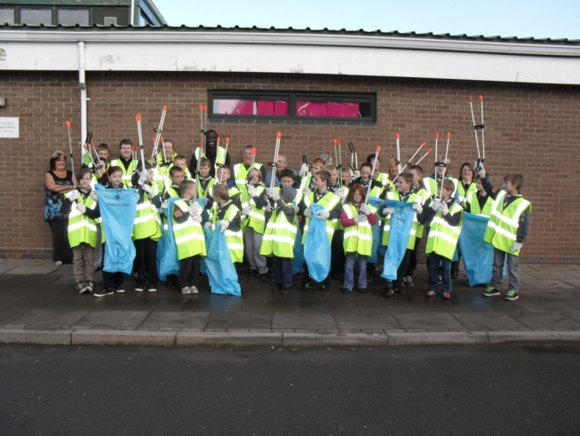
With all of that in mind we have had a busy 12 months hopefully as successful as the last 3 years. We have continued with our Annual Litter Pick and again with the support of Ellowes Hall Sports College who have again given their commitment to us together with the fantastic support we have again had from the 2nd St James Cubs & Scouts, Lower Gornal and one or two of our locals have over the 2 planned days cleaned up the area that the TRA covers, unfortunately it does not last long but we are determined to show that it can be done. We were very privileged to have a visitor this time round, Mr Bob Jones joined us for a couple of hours and commented on the fantastic job that all of us are doing, especially the young people who joined us on that day and we are very proud to say that he has now become the new West Midlands Commissioner for Police (we must have made the difference).
Note for your diary 21 September 2013 is our next Litter Pick.

We continue to attend meetings such as PACT (Police and Community Together) on a regular basis, the new Community Forum and at every opportunity put forward any concerns on behalf of our community and encourage everyone to attend these important meetings for themselves as well.

We have representation on the Patient Practice Group at our local doctors and this hopefully will strengthen our commitment to yourselves and again gives us the opportunity to put forward any concerns on your behalf.

We have representation on other groups such as the new communication group that the Council has introduced. This gives us the opportunity to be first to see any publications that will be distributed to tenants and ensure that the correct information in the right format is published.

We have representation on the new Anti Social Behavior Unit, this is vital to all of the community to ensure that the correct procedures and decisions are made for the whole of the Dudley Borough and that anyone who is involved in having to report any problems the process is made easier and uncomplicated as possible. We hope that anyone who is affected by this is helped and guided without any further stress to themselves.

We have representation on the Welfare Reform Group and again this gives us the opportunity to put forward any concerns first hand and gain any valuable information that we can pass down to yourselves in our official meetings.

In September 2012 5 of our committee members attended the “Take Control” Conference held at Brierley Hill Civic Hall where it gave us insight into the processes and decisions the Council have to make. The day it self was very interesting and most importantly we were given the chance to be included in the way forward towards any new developments and processes that will be put in place in the future. We will be attending a further meeting the end of June to continue being involved in this.

Our aspirations for the next 12 months are to introduce more dog fouling bins, look at areas that require more lighting such as the walkways between Boundary Hill to Brookdale and Brookdale to Summer Lane. We also felt that it was the right time to look at larger projects for the area and felt that one of the items that is missing in our area is a place for the younger children to play in and on that decision we are looking at the possibility of a toddler’s play area. This will not be an easy project but we are determined to try our best to see how this can be achieved. We thank the help and support from our local Councillors who are helping us step by step to receive confirmation from the Council and hopefully we will be able to require funding to support this project. We hope that we gain support from the local area in the proposed project and that the end product will be worthwhile not just for the children but for the community, to strengthen what we are all working towards, a community to feel safe in and be proud of.

Like a lot of areas there is always an element of anti social behavior but we would like to think that since we started the TRA that we have had some input into trying to control this issue by attending meetings and at every opportunity working towards diluting the problem. We can only emphazise the importance of reporting any issues to the Police, by attending meetings and bringing up any issues that are affecting the quality of life that we live. The evidence is very critical in helping the Police to issue any orders that may be required and although in some cases it may seem that there does not appear to be anything happening we can reassure you that this is not the case.

We have not been able to produce a newsletter since the last AGM but can reassure you that this will be back this year and hopefully will contain our success and any other useful information for you. So watch out for this coming through your door in the next few months.

June 1 – 7 was Volunteer Week which celebrates the good work that volunteers do and it has given us the opportunity to thank our volunteers for the help and contribution they give to us at our Annual Litter Pick. We have had the pleasure in presenting certificates to both Ellowes Hall Sports College and to the 2nd St James Cubs & Scouts, Lower Gornal for their commitment over the last 2 years to the litter picks. A very big thank you to you all.

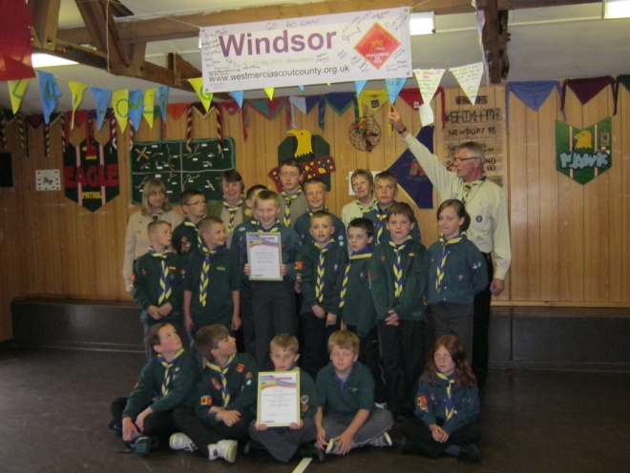
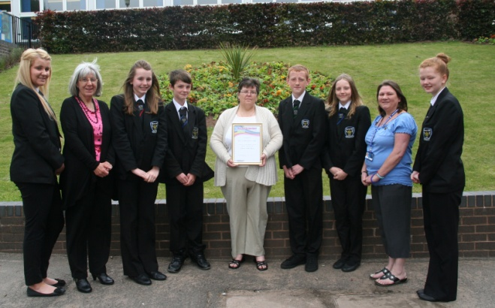

We hope that the above gives you an insight as to why we are a TRA and what we are trying to do for the community. For us to continue with all of this it is important that we have support from the local people to our official meetings and for that we once again thank you. We are very committed to the challenges that face us and with the support that you give us we will continue to make a difference for us all.

