AGM -26 JUNE 2014 CHAIR’S REPORT

With the continued support from yourselves we have now reached our 5th year as a TRA. Our commitment and aspirations are still very much our priorities for us all to live in a safe environment and for us all to have a quality of life to enjoy our community.

We are very fortunate in that we have continued support from the Police our Housing Managers and Councillors and for that we would like to thank them and hope the support continues through the next 12 months.

Once again we would also like to say a big thank you to the Participation Development Team for their continued support that we have been given to us from the start. Their continued guidance has been fundamental to the existence of our TRA and although we are more independent we still value the knowledge that they share with us.

A big thank you to The British Legion Club for the support that they give us in that we are able to hold all our meetings at their venue.

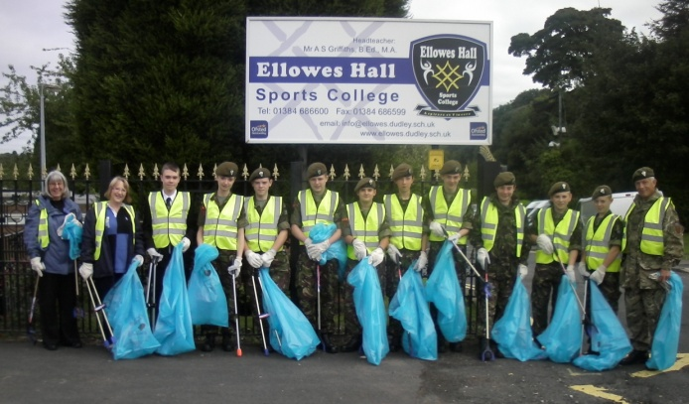
We again have had a busy 12 months and have continued with our Annual Litter Pick and for the first time in September we were joined by the Cadets from the Ellowes Hall Sports College and together with the continued support from the 2nd St James Cubs & Scouts, Lower Gornal and one or two of our locals have over the 2 planned days cleaned up the area that the TRA covers, unfortunately it does not last long but we are determined to show that it can be done. We cannot thank these young people enough for the support they give us year in and year out together with the enthusiasm they show. It is a hard day for us all but the one thing that makes it all worthwhile is the outstanding commitment from the young people involved. Thank you to them all.

We are hoping to extend the litter pick to two a year next year and if we can put this in place we will be looking at April and September.

DATE FOR YOUR DIARY 27 SEPTEMBER 2014 IS OUR NEXT LITTER PICK.

We mentioned in our last chair’s report that we were very hopeful in taking forward a proposal of a toddler’s play area. After a long and complicated procedure involving letters, consultations and meetings we were informed that the area that we were looking for could no longer be used for this purpose and as you can imagine we were very disappointed in this outcome and at the moment this is on hold. Not beaten yet.

We have requested more lighting to be available for the houses that are positioned very low in Park Road facing the Ellowes Woods for the pathway that leads to these houses to have bollard lighting for safer access to their homes.

We have put in a request from the Community Forum for help towards purchasing and having erected 2 vandal proof notice boards for our area so that we can communicate with our tenants and residents on a more structured way by keeping you up to date with information that is relevant to you. At the meeting on the 23 June we have had the decision deferred for the time being to look into the costs but have been reassured that this will be granted.

As part of the support to commemorate WW1 the Cadets based at Ellowes Hall Sports College have received poppy seeds from Flanders and with the support of the local Golf Club they have been given a dedicate plot of land to plant the seeds and once they are in full bloom they will read “WW1” which will also be seen in its full glory from the air. Congratulations to the Cadets.

We ourselves are very proud in being part of the Remembrance Services that is held in November outside the Memorial Hall by laying a poppy wreath on behalf of the TRA and our community.

Since we came together as a TRA one of the issues that we have continued to support is the tidying up of the overgrown area at the top of Malvern View facing Stickley Lane. This is has been quite a challenge over the 5 years. With the cooperation of the Environment Dept, Housing Managers and Councillors of Dudley we have to date been able to confirm the boundary between council and private land, we have been able to have the litter and fly tipping on the land tidied up, including ourselves on our litter pick. One of the positives that has come out of this is that the car park area at the side of the land has now been made more acceptable to be used for purpose it is intended for.

However on achieving all of the above we still need to have the land kept under control and cut back. We have now approached Ian Austin MP and have meet with him to discuss the land and from the information we have given to Mr Austin he has confirmed that he will look into this on our behalf and will work with our own councillors to see if this can be dealt with and come to some positive conclusion.

We are continuing with our walkabouts in our TRA area and whenever possible our Housing Managers, Police and Councillors join us. This gives us the opportunity to report any problems and issues directly to those who are present and hopefully to be dealt with more quickly. Please do join us on these walkabouts when you see us. Dates for the walkabouts are at the end of this report.

At the request of our Housing Managers we have produced a leaflet to be handed out to new and where necessary existing tenants promoting our TRA explaining that we are here to help and guide on any issues and contacts.

The following meetings and project groups are attend by if not all of our committee members then there is always a committee member present.
- PACT meetings (Police and Community Together)
- Community Forum Meetings
- PPG (Patient Practice Group) based at the Lower Gornal Doctor’s Surgery
- Welfare Reform Group
- Dudley Communication Group
- Dudley Reading Group – this group is involved in the proof reading of most of the material before you receive from Dudley Council as tenants. One example is that of the Home Affairs Magazine that is delivered to all of the tenants in the Dudley borough.
- Anti Social Behaviour Project Team.
- Take Control Project – this is a new initiative which has been introduced and welcomed by Dudley Council to set up a Tenant’s Scrutiny Board and we are pleased to announce that some of our committee members have been successful in being accepted on the interim board for the next 12 months to set up procedures for the Board who will be in place in 2015.

By attending the PACT meetings on a regular basis we receive vital stats that show figures of crime in our area and at the moment this is showing a decline, may this continue. We can only emphasise the importance of reporting any issues to the Police. By attending these meetings this gives us the opportunity of speaking directly to the police and report any issues. Evidence is very critical in helping the Police to issue any orders that may be required and although in some cases it may seem that there does not appear to be anything happening we can reassure you that this is not the case.

As you can see all of the above can only make us a stronger voice for not only the community we live in but also for the Dudley Borough. We are very proud of the continued involvement that we are adding on behalf of our community.

Welcome back to our newsletter which we hope you all received and found informative, this will continue to be published on an annual basis for the time being so please look out for this.

We hope that all of the above gives you an insight as to why we are a TRA and what we are trying to do for the community. For us to continue with all of this it is important that we have support from the local people to our official meetings and for that we once again thank you. We are very committed to the challenges that face us and with the support that you give us we will continue to make a difference for us all.

DATES FOR YOUR DIARY
GENERAL MEETINGS – BRITISH LEGION CLUB- 7pm for 7.15pm start.
23 SEPTEMBER 2014
27 JANUARY 2015
9 APRIL 2015

WALKABOUTS – STARTING AT TOP OF WOOD ROAD.
4 SEPTEMBER 2014 5PM
21 OCTOBER 2014 5 PM
2 DECEMBER 2014 11.30AM
14 JANUARY 2015 11.30AM
19 FEBRUARY 2015 11.30AM

