
CHAIR’S REPORT FOR 2015 / 2016

This is now our 7th year of a TRA and what a busy year we have had. Our usual public meetings and walkabouts have continued and although we are seeing the benefits of the walkabouts in our area we are finding that we are having to reconvene our meetings more and more as the normal way than we have had to in the past. The support of the people in our area is so vital for us to continue as a TRA, especially as we have sadly seen some of the TRAs fold, and we thank you for the support you give us. We would also like to thank the Royal British Legion for their support in the use of their facilities for us to hold our meetings.


We have seen changes in reduction of services from our local council and reduction in the police force however on saying this we do still have a healthy partnership with both our housing managers and the police.

Our litter pick in March was a very special one as we registered on the Clean for the Queen website and had a very slightly dry day and armed with our PURPLE bin bags we collected 30 bags in total. Our next litter pick will be on Saturday 24 September.

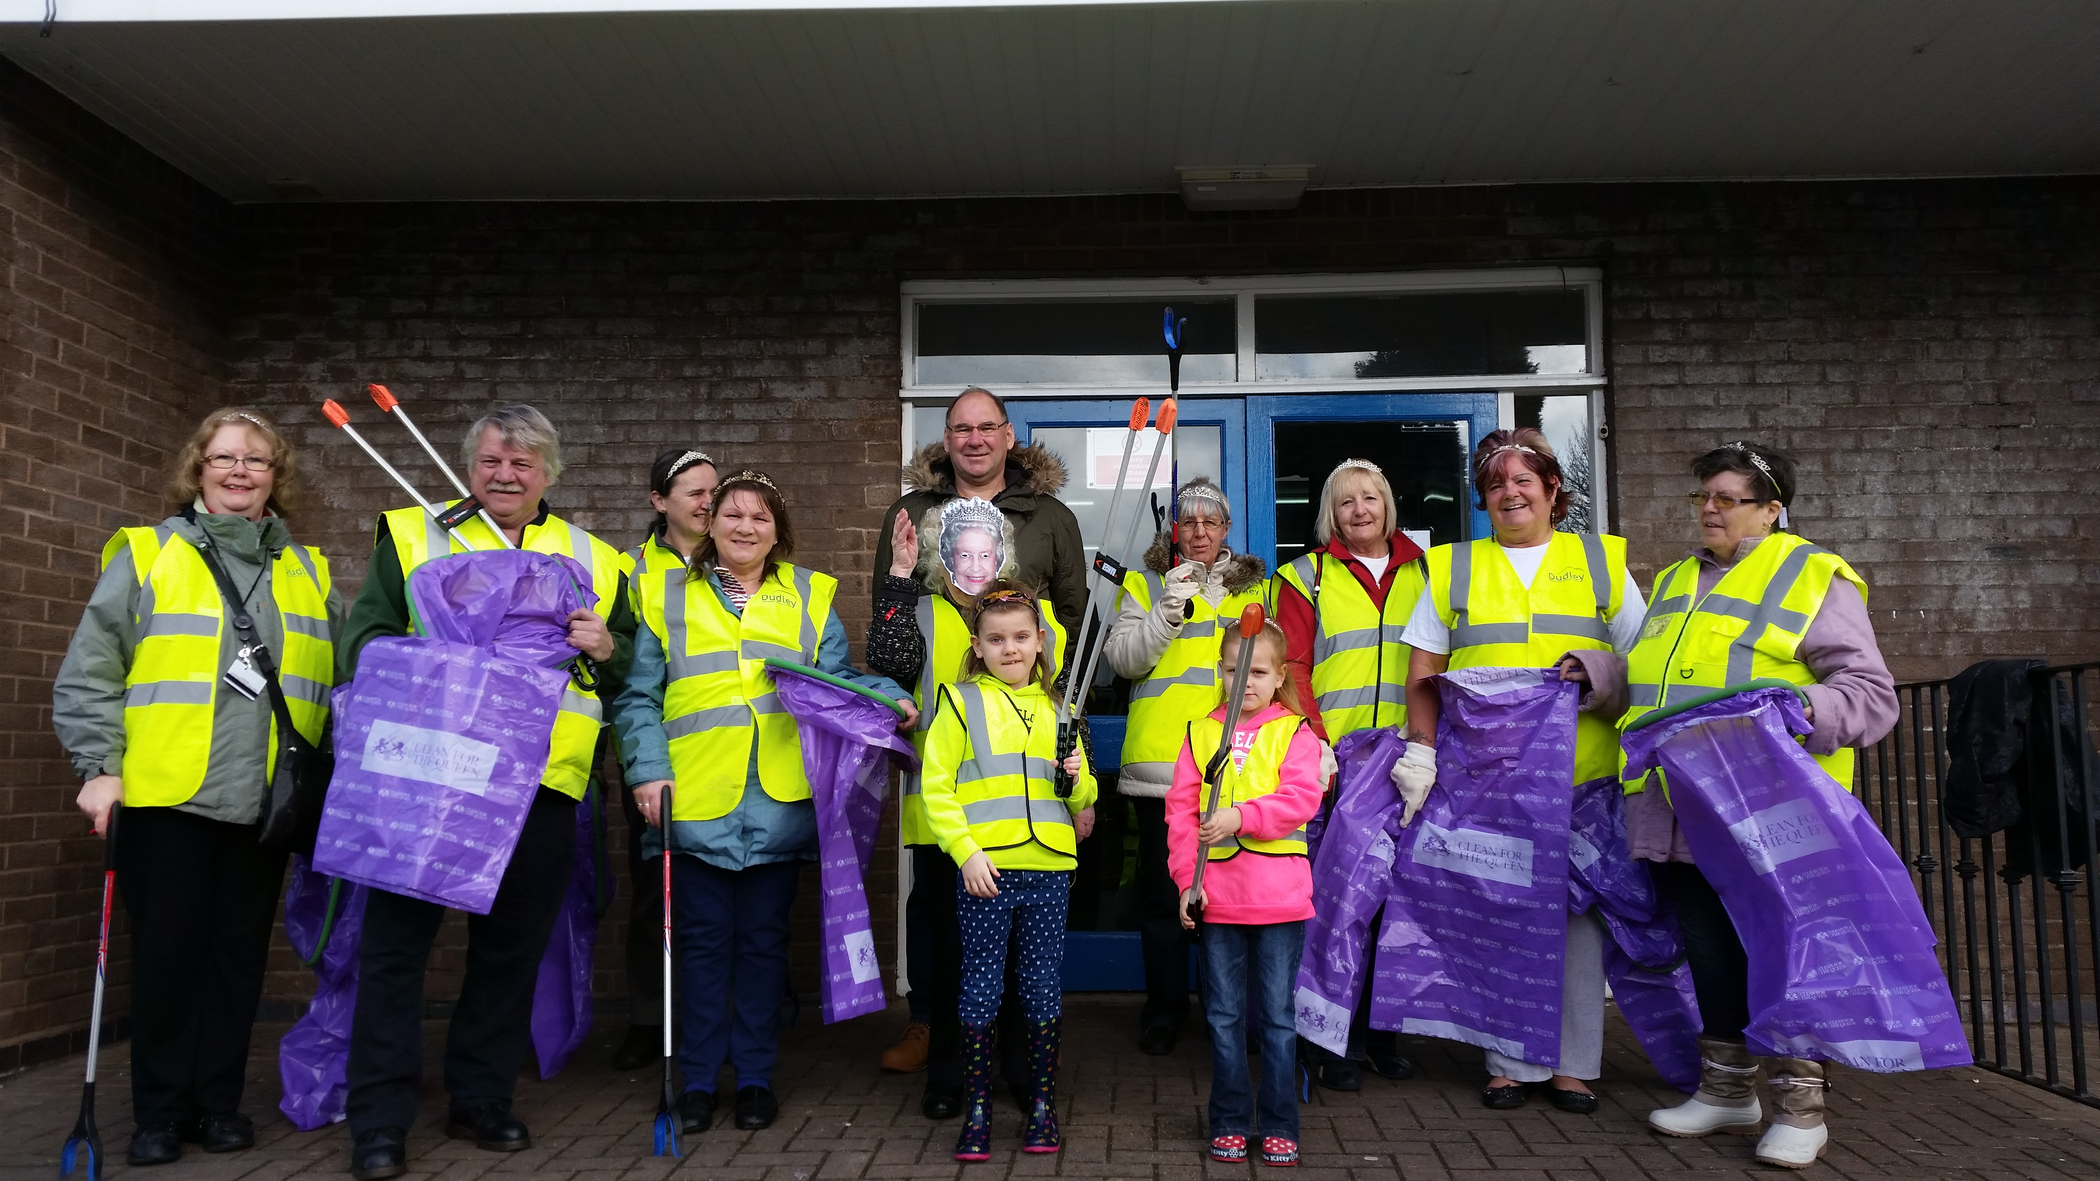
Although we try to do what we can for our community we have over the past few years looked at ways we could become more involved We felt one of the ways we could achieve this was to work in partnership with the Friends of Cotwall End Valley Group, as part of the valley is within our TRA area. This decision has not only strengthened our work within the community but has also given us a chance to look at different ways in connecting with the wider community.

From this partnership we have successfully organised a dedication service which honours our local heroes who have fallen in battle. This service takes place the following Sunday after Remembrance Sunday this year it will be Sunday 20 November. A tree, plaque and bench can be found in the valley. We have again jointly organised a Teddy Bear’s Picnic and although the weather was not in our favour those who attended had a fantastic day. Many more to come.
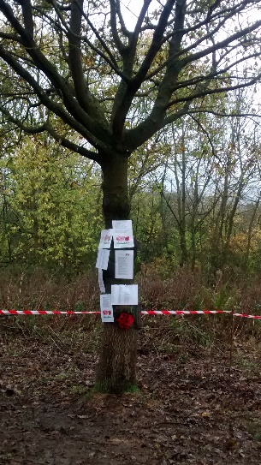
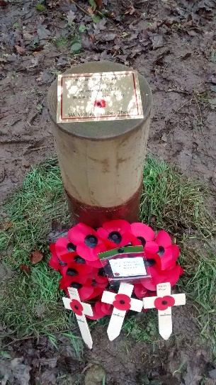
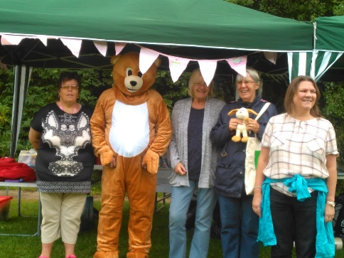
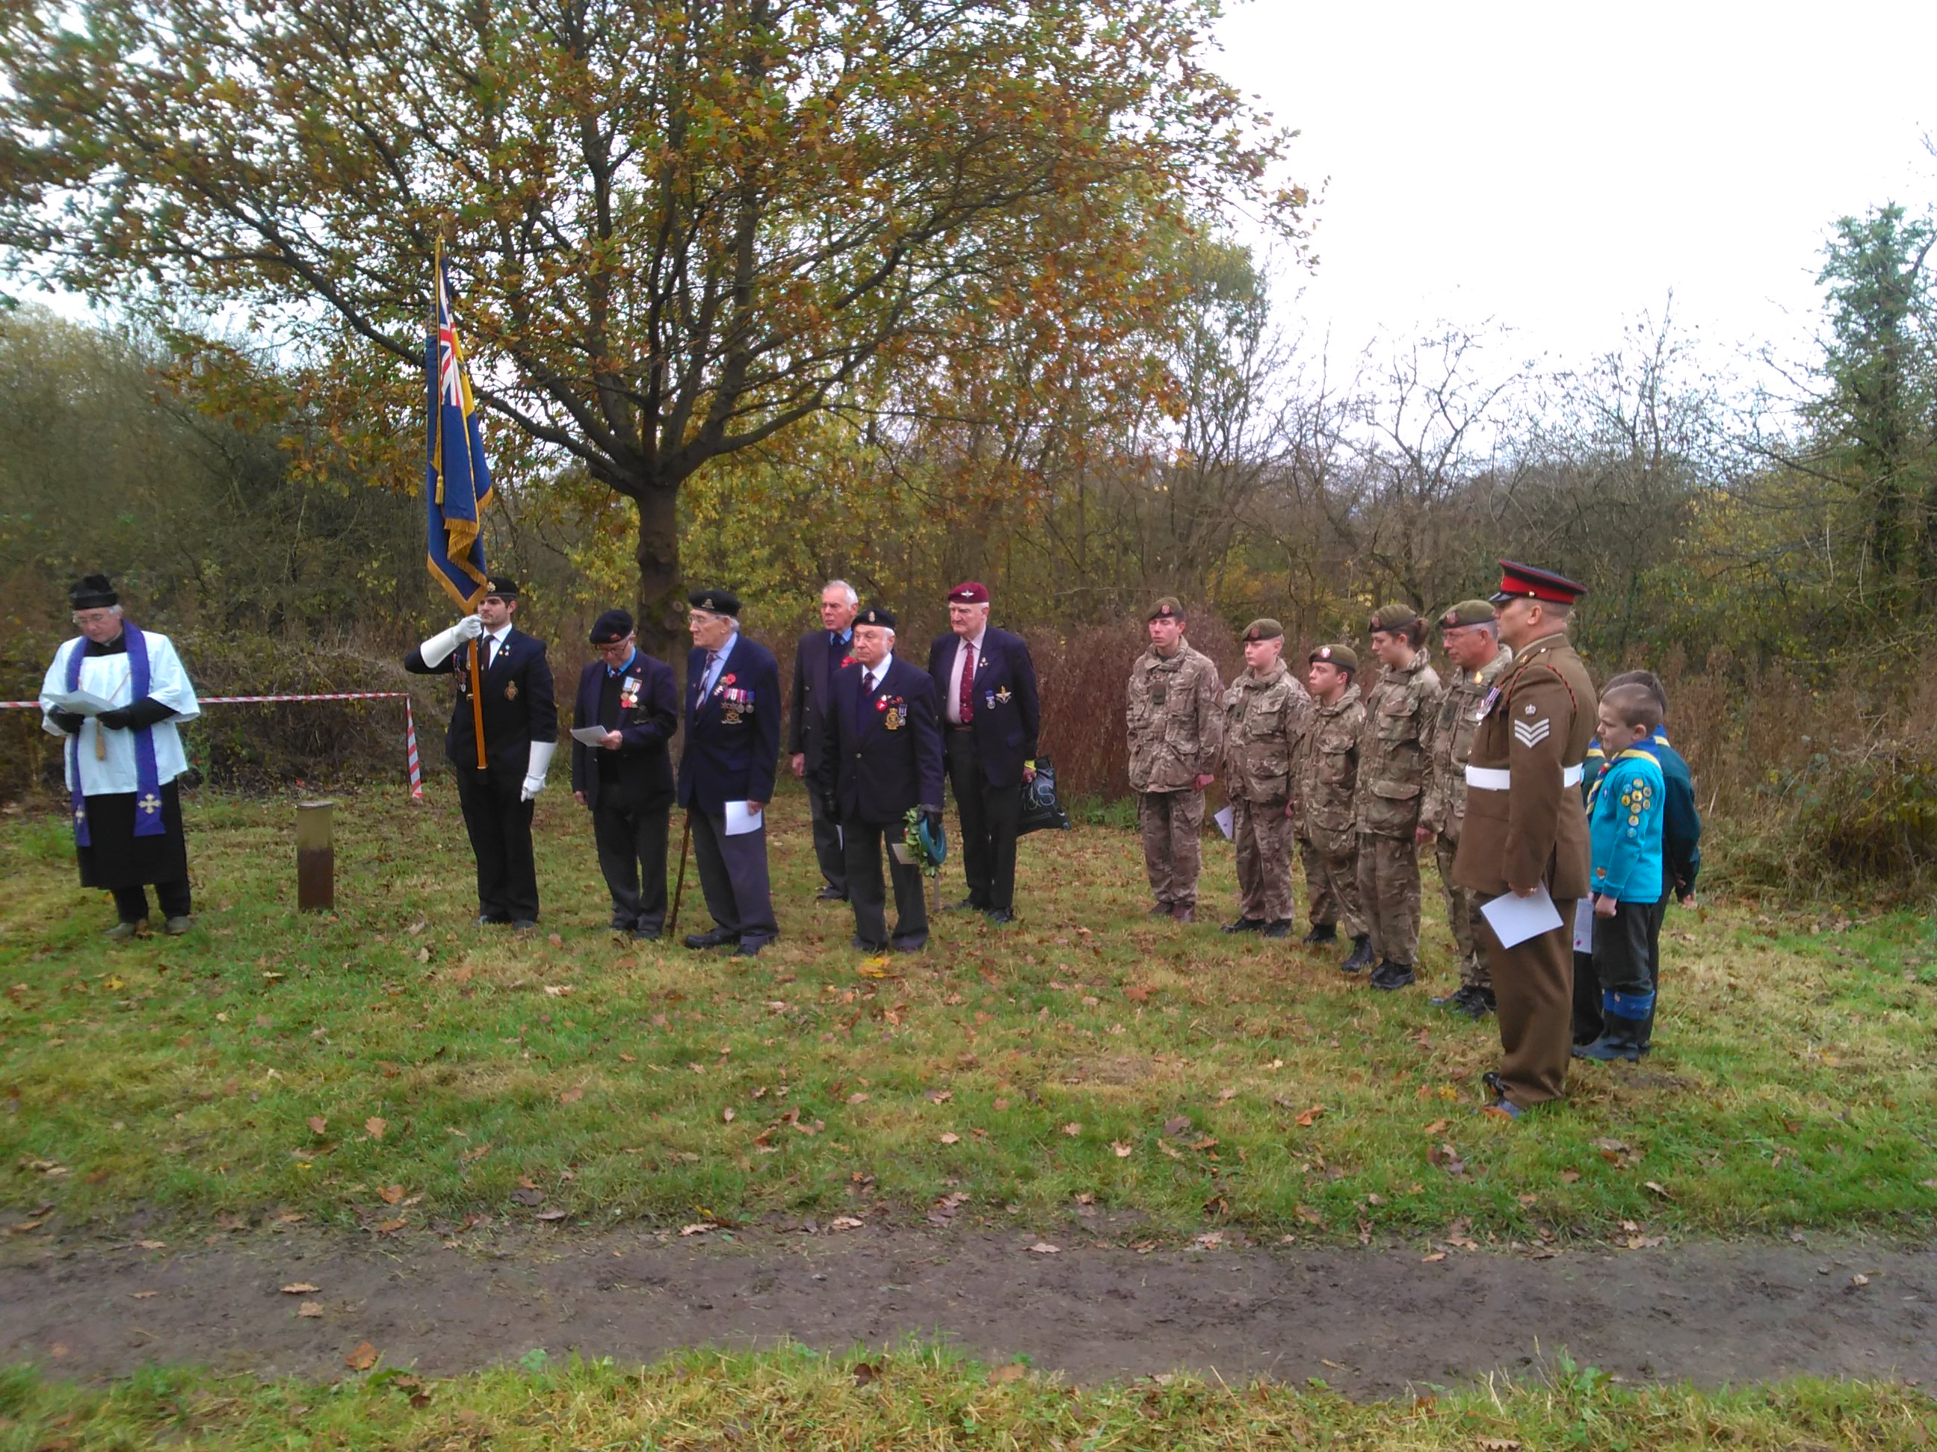
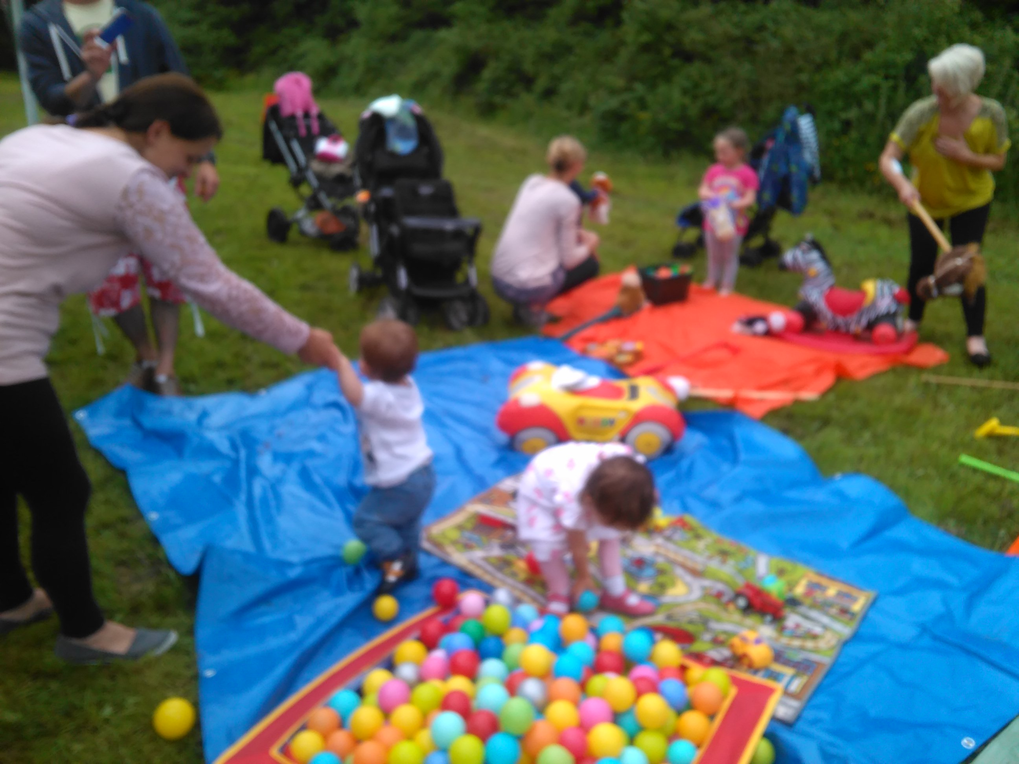

One of the larger projects we have undertaken through this partnership is to support St James’ Church by helping to tidy up the churchyard. Due to ill health the gardener has had to retire and the churchyard was unavoidably neglected, so together with the new appointed gardener we have started the tidying up process. As we have continued with this project we have had more and more of the public join us, thank you.


